DOCKER INSTALLATION STEPS

Step-1:
- $ sudo apt update

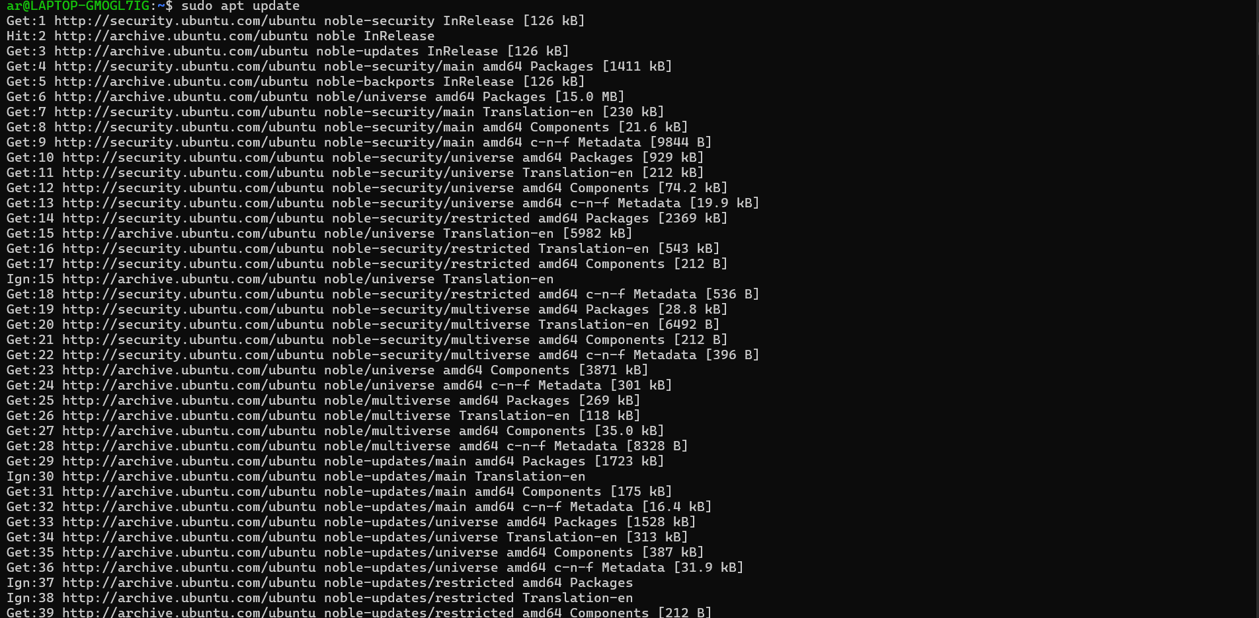

Step-2:

- $ sudo apt install docker.io

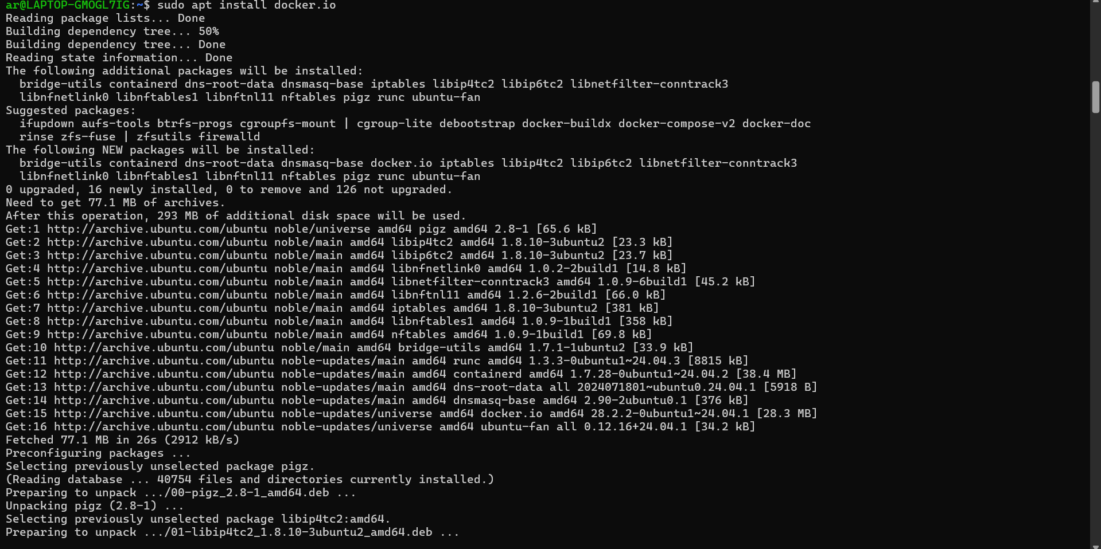

Step-3:
- $ sudo systemcall start docker

Step-4:
- $ sudo docker ps

